**Mission: *Enable Corps staff to anticipate, prevent and manage water-related conflicts through collaboration while ensuring that the interests of the public are addressed in a fair and transparent manner.***

**GOAL 1:** *Build the collaborative capacity of Corps staff and partners to enable effective convening of, and participation in, collaborative processes.*

***Led Collaboration and Public Participation Community of Practice (CPP CoP)***

* Built collaborative skills for 650+ member CoP through publication of three newsletters, monthly update email and multiple webinars.
* Supported new 16-member CPP CoP Steering Committee to address External Collaboration, Internal Collaboration, and Information Sharing challenges.
* Received leadership and financial support and developed initial draft for a USACE-wide Public Participation Policy.
* Garnered leadership and financial support for the Gnarliest Collaboration Challenge to provide technical support to solve difficult collaboration problems.

***Delivered Trainings to more than 1200 USACE Staff***

* Delivered *Public Involvement & Teaming in Planning* course twice; *Effective Communication for Regulatory* training four times; *Facilitation & Multi-Party Skills for Working with Tribes* course twice; and *Risk Communication and Public Involvement* course.
* Designed *Levee Safety Risk Communication Training Workshop* and delivered it to 18 Districts.
* Delivered *Collaboration & Conflict Transformation in Multi-Party Processes*, an interagency training hosted with USFWS at the National Conservation Training Center and at South Pacific Division.
* Designed and led *Workshop for Lower Mekong Initiative on Public Participation, Collaboration and Conflict Transformation* in conjunction with Pacific Ocean Division and the Department of State.
* Designed & taught *Teambuilding and Leadership* for Planning Associates (PA); taught *Shared Vision Planning* module of the PA Watershed class.
* Led seven “Coaching Calls” on various topics for Levee Safety risk communication.
* Provided training with Public Involvement Specialists at Public Affairs and Program & Project Management CoP workshops.

***Managed the Public Involvement Specialists Program***

* Led the third year of the Public Involvement (PI) Specialists program. Identified and supported subject matter experts at the District-level to provide direct technical assistance, assess collaboration needs, and increase skills.
* Expanded program to 21 PI Specialists who provided direct assistance to more than three dozen projects.
* Hosted PI Specialist meeting to increase skills; organized workgroups to develop products to support PI Specialist activities.

***Built Awareness of Availability and Value of Collaborative Resources & Processes***

* Developed several one-hour “*Brown Bag Training”* modules for PI Specialists to deliver in their Districts to increase awareness of collaborative skills, techniques and resources.
* Created a series of 2-page *Value of Collaboration* fact sheets customized for different business lines.
* Wrote articles on the Multi-Hazard Tournament & Flood Risk Communication Toolbox for the Silver Jackets & FRM newsletters.
* Developed CPCX brief for MSC liaisons to deliver to incoming Division Commanders
* Published Primer, *How to Identify and Engage Socially Vulnerable Communities.*

**GOAL 2:** *Increase the success of collaborative processes for activities conducted by the Corps and its partners by providing direct support.*

***Provided Sustained Technical Assistance to Districts, Divisions & National USACE Programs***

* Provided facilitation and mediation support for Jacksonville District’s *Everglades Restoration Transition Plan and Biological Opinion on the Cape Sable Seaside Sparrow.*
* Led Shared Vision Planning activities for Honolulu District’s West Maui Watershed Study.
* Supported St. Paul District’s *Regulatory for Tribal Consultation* programs and meetings in conjunction with USIECR.
* Conducted *Federal Employee Viewpoints* survey and facilitated focus groups to recommended improvements for IWR.
* Conducted four workshops to support Walla Walla District and the City of Pocatello, Idaho’s Portneuf River Vision Study.
* Facilitated two public meetings for Omaha District’s Cherry Creek Dam Water Control Plan Modification Study.
* Developed a collaborative path forward with Apalachicola Chattahoochee Flint Stakeholders, Mobile District, South Atlantic Division, USGS, local universities & NOAA that does not trigger concerns over the master manual rewrite or the ongoing lawsuit.
* Provide facilitation and meeting design support for the *Chesapeake Bay Comprehensive Study* for Baltimore District.
* Facilitated ERDC invasive species meeting, a USFWS meeting on migratory bird issues, an after-action meeting on Miami Harbor and an offsite for the Middle East District.
* Designed and facilitated multiple SMART Planning charrettes.

***Enabled Access to Facilitators and other Resources***

* Responded to more than a dozen District requests for facilitators or other resources by referring them to the “Find a Facilitator Database,” local Public Involvement Specialists, or USIECR.
* Provided pro-bono, on-call advice to Districts on virtual and in-person collaboration and interactive techniques 30 times.

**GOAL 3:** *Advise Corps leadership in designing, implementing and investing in effective collaboration.*

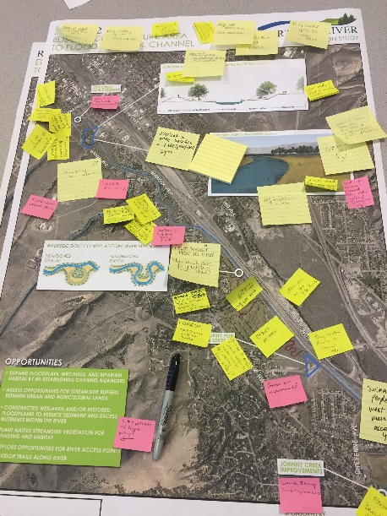

***Supported Special HQ & ASA-CW Initiatives***

* Led Public Involvement and Communication Team for USACE Levee Safety program
* Met with HQ-USACE on Risk Communication Needs for the FUDS program and for Interagency Collaboration opportunities within the Urban Waters Program; identified a path forward for supporting each initiatives.
* Supported Watershed Informed Budgeting Stakeholder Engagement.
* Revised *Planning Guidance Notebook Appendix B: Coordination, Communication and Collaboration.*

***Assessed the Corps’ capacity to collaborate with internal and external stakeholders***

* Published *USACE Collaborative Capacity Assessment Report.*
* Published *Assessment of the Public Involvement in Flood Risk Management Pilot Program.*
* Finalized redesign of OMB-approved interagency surveys to evaluate facilitated processes.

***Served as the Corps’ representative for external coordination and reporting on collaboration***

* Led Corps participation in CEQ’s quarterly Environmental Collaboration & Conflict Resolution Forum.
* Produced 2015 Report to OMB/CEQ on *Use of Environmental Collaboration & Conflict Resolution in USACE.*
* Presented at Association for Conflict Resolution’s Environmental and Public Policy Section and assumed organizational leadership role.

**GOAL 4:** *Establish the Corps as a thought-leader in collaboration by building the knowledge necessary to address future challenges and embrace opportunities.*

***Developed innovative applications of technology in collaboration***

* Produced webinars & newsletters on e-collaboration platforms and social media.

***Piloted innovative approaches to meet emerging issues and future challenges***

* Designed and implemented the Iowa-Cedar Multi Hazard Tournament in collaboration with Rock Island District, the City of Cedar Rapids, NOAA, USGS, DOE, and multiple other partners. The tournament used Shared Vision Planning principles to promote stakeholder discussions of tradeoffs on flood, drought and other water resource risks.
* With ICIWaRM and Global Water Partnership (GWP) TEC initiated plans for a prospective paper and 2017 forum through AWRA on advances in collaborative modeling including use of scenarios, use of gaming, and international experiences.