Communications Update
U.S. Army Corps of Engineers
Institute for Water Resources
On the Web: For More Information:
http://www.iwr.usace.army.mil +1 (703) 428-9090

March 13, 2017

Total Solar Eclipse 2017: See it on Corps Lakes

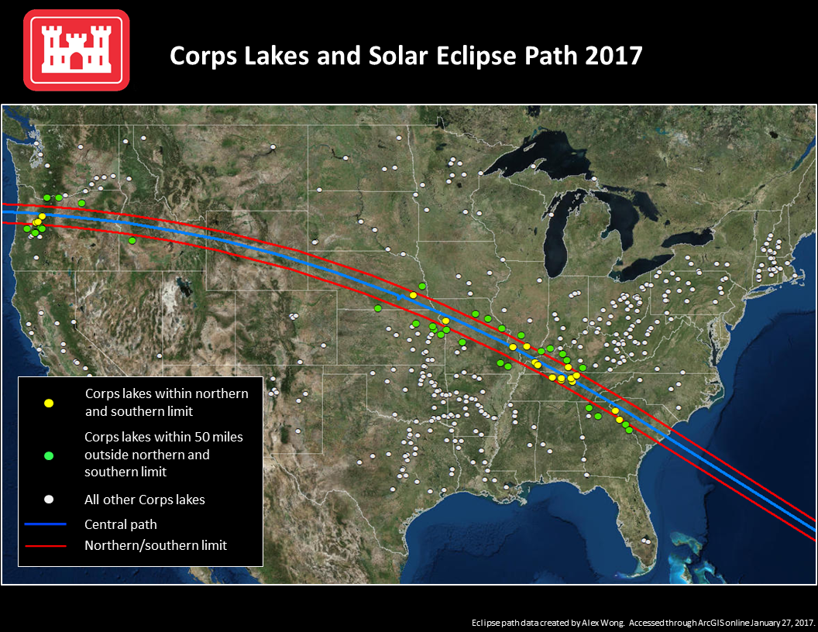
ALEXANDRIA, VIRGINIA. On Aug. 21, 2017, a total solar eclipse will be visible from the continental United States for the first time in 38 years and will cross 14 states along a roughly 67-mile wide path from Oregon to South Carolina. This amazingly rare cosmic event will bring visitors from all over the world to the U.S. to witness this short-lived, yet impactful phenomenon. And since the path aligns with many U.S. Army Corps of Engineers (USACE) lakes containing recreational facilities, these lakes will be prime viewing destinations for the solar enthusiasts and the general public.
The map shows the path of the eclipse along the lakes that are within 50 miles of the centerline of the eclipse’s path.
Visitors to the recreation sites should anticipate significant influxes and a rush to reserve campsites and other facilities (Recreation.Gov). Reservation bookings are now available and there be no extra change the current fee structure for the duration of this event. Visitors who wish to view the event from non-fee areas open to the public will not be charged any fees for viewing the event. Be sure check for festivals and organized viewing events in area.
A total solar eclipse is unlike anything you've seen in your life. As totality approaches, you will see the astonishing sight of day turning to night and the Sun's corona blazing in the sky. This is truly a great American eclipse because totality will sweep the nation from the Pacific to the Atlantic. Nearly everyone in the US can reach this total solar eclipse within one day's drive. An eclipse is a cosmic billiard shot — the Sun, Moon, and Earth line up to reveal the Sun's atmosphere, its corona. Eclipses on Earth occur only because of an amazing celestial coincidence. - www.greatamericaneclipse.com

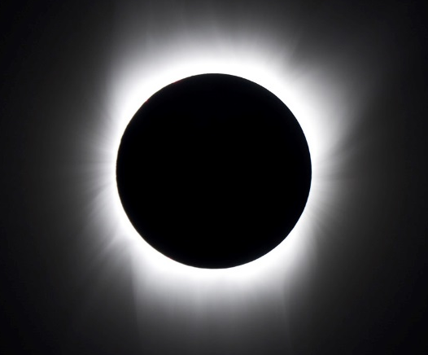
During a total solar eclipse, the moon covers the entire disk of the sun and only the sun’s corona is visible for a moment in time. It is important to remember that to safely watch the partial stages of the eclipse, you must have proper eye protection.
The USACE is one of the nation's leading federal providers of outdoor recreation with more than 400 lake and river projects in 43 states. Visitors of all ages can enjoy traditional activities like hiking, boating, fishing, camping and hunting, and for those slightly more adventurous there is snorkeling, windsurfing, whitewater rafting, mountain biking, and geo-caching.
The next total solar eclipse viewable from the continental United States will be on January 25, 2316 so you won’t want to miss it this year!
Learn More
For more information, visit IWR www.iwr.usace.army.mil
- USACE Recreation Website
- Recreation.Gov Website
- NASA Eclipse Website
- Path coordinates table (NASA)
- The Great American Eclipse
- National Operations Center of Excellence
- US Department of Transportation

The U.S. Army Corps of Engineers (USACE) Institute for Water Resources (IWR) was formed to provide forward-looking analysis and research in developing planning methodologies to aid the Civil Works program. IWR is a field operating activity under the supervision of the Director for Civil Works, USACE.

